Republic of the Philippines Bicol University



**POLANGUI CAMPUS**

Polangui, Albay [www.bupolangui.com](http://www.bupolangui.com/)

# **SOFTWARE DESIGN**

# **Midterm Laboratory Exam**

KENNETH GONZALES

BSCPE-2A

**E-Commerce Website Project**

Website Name:

C++ (Coffee Plus Plus)

**MODULE 2: Product Catalog Management System**

For our e-commerce website project focused on an online coffee shop, it is essential to have a comprehensive product catalog management system that will allow the business to effectively and efficiently manage their product offerings. This module will provide the administrator with the capability to add new products, update existing product information, and manage inventory levels, thus ensuring that the customers receive the best possible shopping experience.

1. **FLOWCHART**

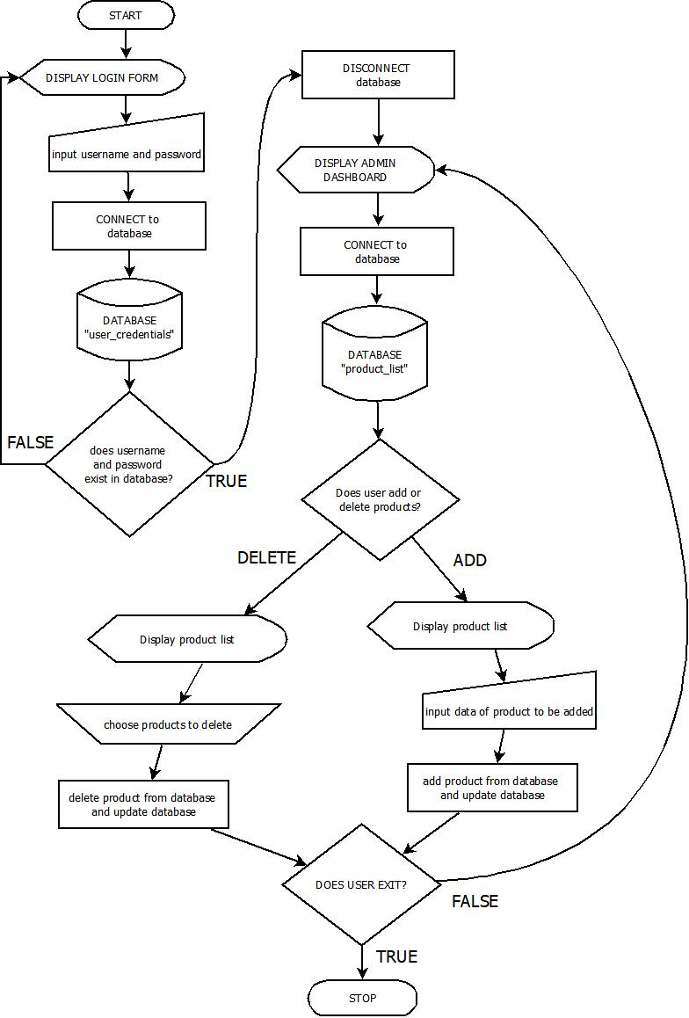In this flowchart, it is evident that the user will initially be presented with a login form prompting them to enter their credentials. The program then connects to the database named “user_credentials” in order to validate the credentials entered by the user. If the credentials are valid, the “user_credentials” database is disconnected and the user is directed to the websites main dashboard. Upon reaching the main dashboard, the user or administrator will have the ability to add or delete any desired products.

1. **HIPO**

This HIPO diagram illustrates the three essential stages of the process of updating a database with new product information using admin credentials, an add/delete command, and product information. The system first authenticates the admin credentials, processes the add/delete command, and then generates an updated database with new product information as the output. Overall, this diagram provides a clear and concise visualization of the critical steps involved in this data processing pipeline.

**INPUT**

**-ADMIN CREDENTIALS**

**-ADD/DELETE COMMAND**

**-PRODUCT INFORMATION**

**PROCESS**

**-AUTHENTICATE WETHER CREDENTIALS ARE VALID**

**-PROCESS COMMAND EITHER ADD OR DELETE**

**OUTPUT**

**-UPDATED DATABASE BASED FROM THE COMMAND ADD/DELETE WITH THE NEW PRODUCT LIST AND INFORMATIONS**

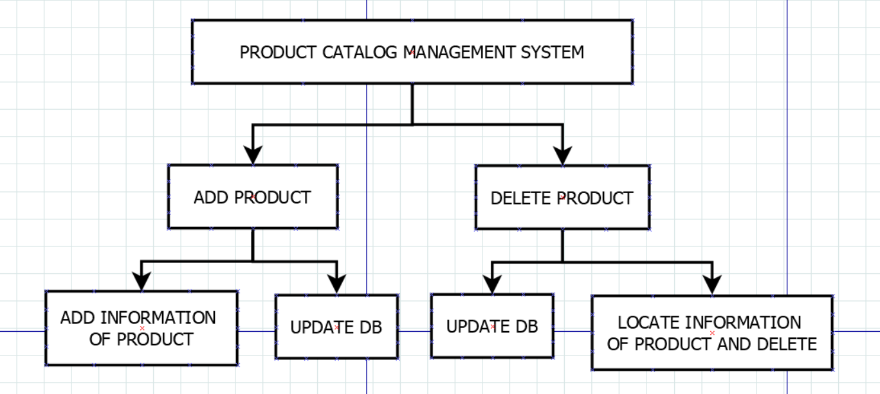

1. **DECISION TABLE**

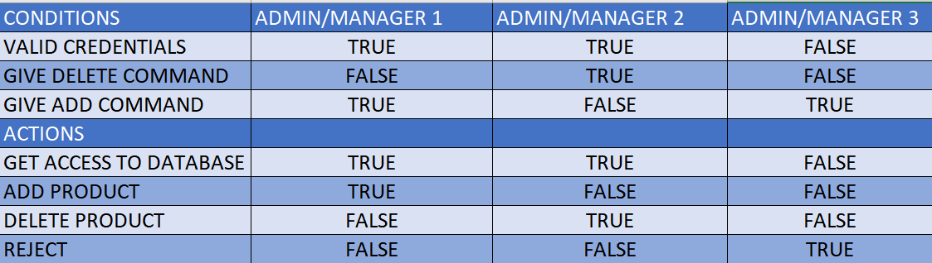This decision table is designed to provide access to a database, depending on the credentials and commands given by an administrator or manager. If valid credentials are provided, both Administrators/Managers 1 and 2 will be granted access to the database, whereas Manager 3 will be denied. When giving a delete command, only Manager 2 will be allowed to delete a product from the database, and when giving an add command, only Manager 3 will be allowed to do so. Lastly, if all other conditions are false, then Manager 3’s request will be rejected.

1. **DATA DICTIONARY**

This data table contains information about products, including a unique product ID, the name of the product, the production time, calories contained, the price of the product, a description and an uploaded image file.

• **Product_ID:** Integer, 10, Primary, Unique identifier

**• Product_name:** Varchar, 50, Not null, The name of the product

• **Product_time:** Integer,50, Not null, Production time of the product

**• Product_calories:** Varchar, 10, Not null, the number calories contained in the product

**• Product_price:** Integer, 50, Not null, The price of the product

**• Product_description:** Text, 50, Not null, A description of the product

**• Product_image:** Image/PNG, Not null, An uploaded image file of the product in the database.

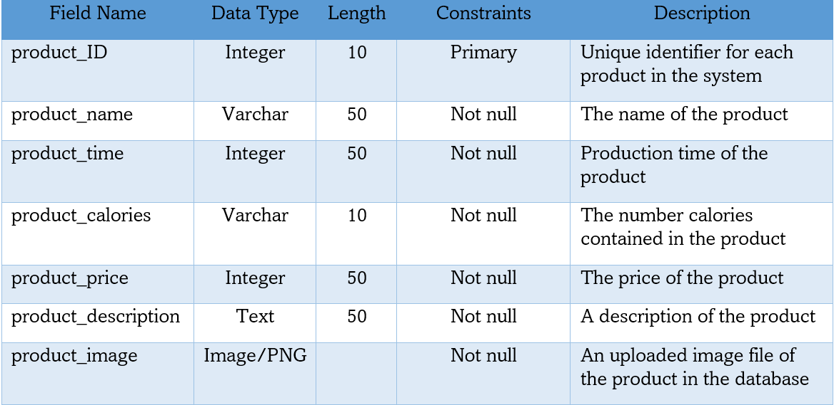

1. **DATA FLOW DIAGRAM**

This Product Catalog Management System dataflow system diagram designed to manage products within a dashboard database system. It allows users, typically an administrator, to add or delete products from the database which is then accessible via the program for modification. Once a product is added or deleted, the program will access the database and update the list accordingly, displaying the updated list back to the user or administrator. This process provides a convenient and efficient way of managing product catalogs with minimal effort.

